DNA, Genes, and Exon Coordinates — Biology Background

1. What is DNA?
DNA (Deoxyribonucleic Acid) is the molecule that carries genetic information in all living organisms.
It is composed of four nucleotides represented by the letters A, T, G, and C.
These nucleotides form long chains, which encode the instructions for building proteins and regulating cellular processes.

2. Genes, Exons, and Introns
A gene is a specific region of DNA that can be transcribed into RNA and translated into a protein.
In eukaryotic organisms (such as humans), genes are often divided into coding and non-coding segments:
- Exons: The coding portions of a gene that remain in the final mRNA after RNA splicing.
- Introns: Non-coding sequences that are removed during RNA processing.
During transcription, DNA is copied into a pre-mRNA molecule that includes both exons and introns.
Splicing removes introns, joining exons together to create a mature mRNA sequence.

3. What Are Exon Coordinates?
Exon coordinates describe the start and end positions of exons within a DNA sequence.
They are used to mark which parts of the DNA correspond to coding regions.
Example:
For a DNA sequence "atgcgatgcgatgcg", an exon coordinate of (2,5) means the bases from position 2 up to (but not including) 5 are part of an exon.

Example Python illustration:
dna = 'atgcgatgcgatgcg'
exons = [(2,5)]
annot = list(dna.lower())
for s,e in exons:
for i in range(s,e):
annot[i] = annot[i].upper()
print(''.join(annot))
# Output: atGCGatgcgatgcg

4. Why Exon Coordinates Matter
Understanding exon coordinates is essential for genomic data analysis, gene annotation, and bioinformatics programming tasks such as:
- Extracting coding regions from genomic sequences
- Annotating and visualizing gene structures
- Comparing alternative splicing patterns between transcripts

5. Canonical Splice Sites
Exon–intron boundaries often follow specific nucleotide patterns:
- Donor site (5′ end of intron): usually starts with "GT"
- Acceptor site (3′ end of intron): usually ends with "AG"
These patterns help cellular enzymes recognize where to cut and splice.
They are conserved across most eukaryotic species.

6. DNA → pre-mRNA → mRNA (Visual Concept)
DNA: [---Exon1---][---Intron---][---Exon2---]
│ │
Transcription → pre-mRNA: [---Exon1---][---Intron---][---Exon2---]
│ (Splicing removes intron) │
Mature mRNA: [---Exon1---][---Exon2---]
This diagram shows how splicing connects exons together while removing introns, producing the final coding message (mRNA) used in protein synthesis.

7. Further Learning Resources
- Anatomy of a Gene (Learn.Genetics) – clear visuals showing exons/introns and splicing.
🔗 https://learn.genetics.utah.edu/content/basics/geneanatomy/
- Ensembl Exons & Introns Tutorial – step-by-step guide to exploring exon structures.
🔗 https://www.ebi.ac.uk/training/online/courses/ensembl-browsing-genomes/navigating-ensembl/investigating-a-transcript-splice-variant/exons-and-introns/
- UCSC Genome Browser Tutorial: Getting Exon Coordinates – practical tutorial for retrieving exon sequences.
🔗 https://training.incf.org/lesson/how-do-i-get-coordinates-and-sequences-exons
- RNA Splicing Animation (DNALC) – 3D animation showing the splicing process.
🔗 https://dnalc.cshl.edu/resources/3d/rna-splicing.html

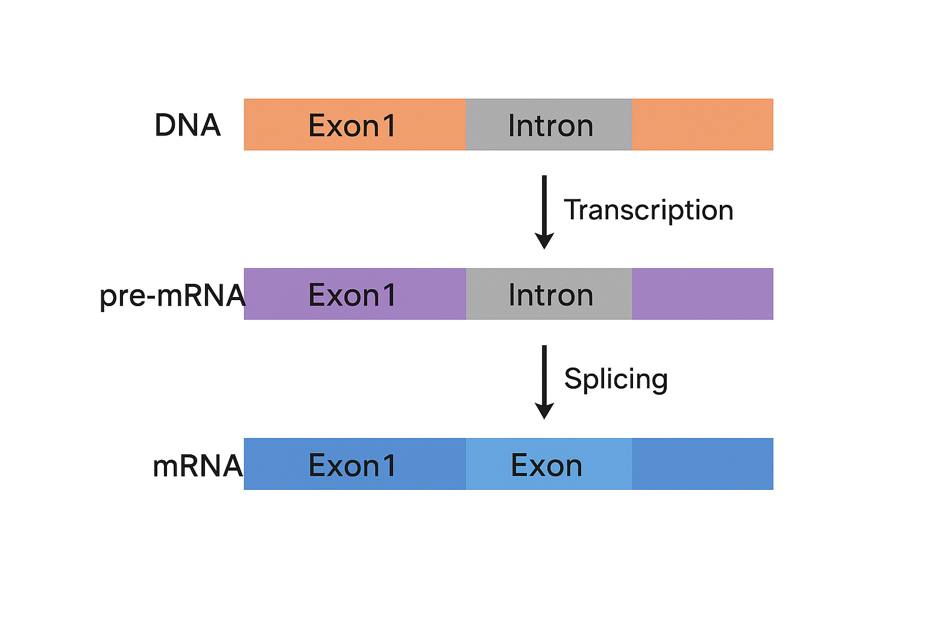
Title: Introns vs Exons
It gives a clear visual of what introns and exons are, how they relate to transcription and splicing.
Here’s a great YouTube video (high view / solid explanation):
https://youtu.be/_asGjfCTLNE

